ARMIDALE ACCOMMODATION GUIDE

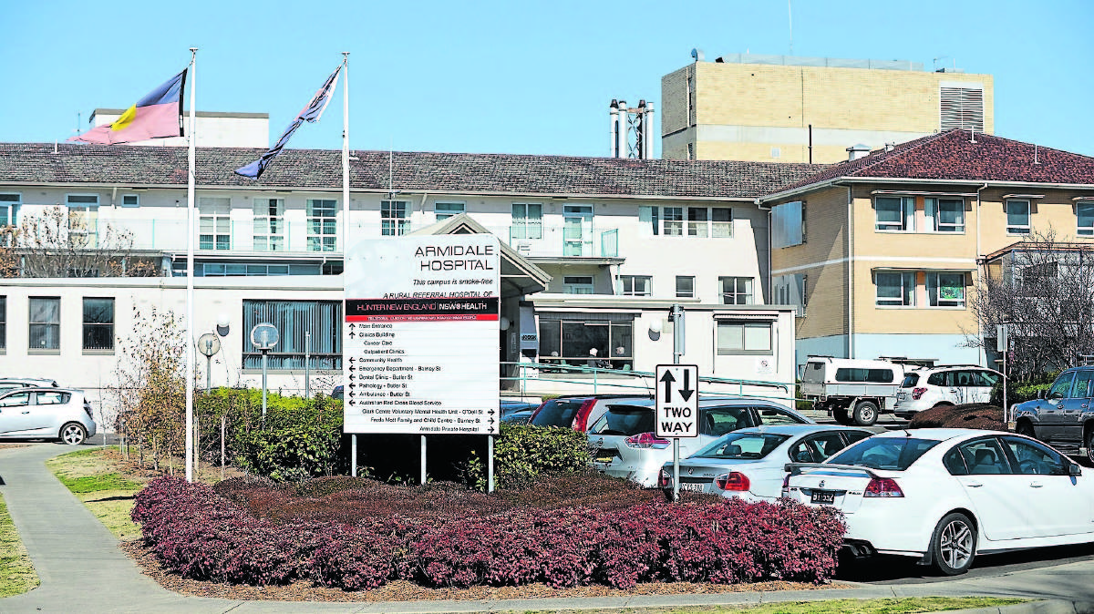
The Northern Daily Leader (2016) HOSPITAL FRONT ENTRANCE

SOCIAL WORK DEPARTMENT – ARMIDALE RURAL REFERRAL HOSPITAL

Armidale Public Hospital
226 Rusden Street, Armidale, NSW 2350
(02) 6776 9500

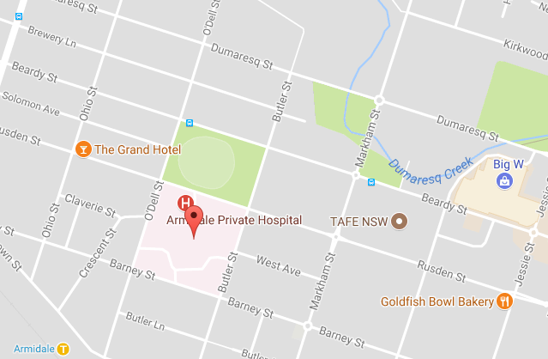

ARMIDALE ACCOMODATION GUIDE
All prices are subject to change. It is recommended you ask for current prices in case of a change.
Abbotsleigh Motor Inn  76 Barney St  6772 9488 | PRICE LIST  Budget Room - $105  Executive Room- $135  Family Suites- $186 - 4 people  $ 10 per extra person | KM’S FROM HOSPITAL  1.6 km’s  4 minute drive from the Hospital | 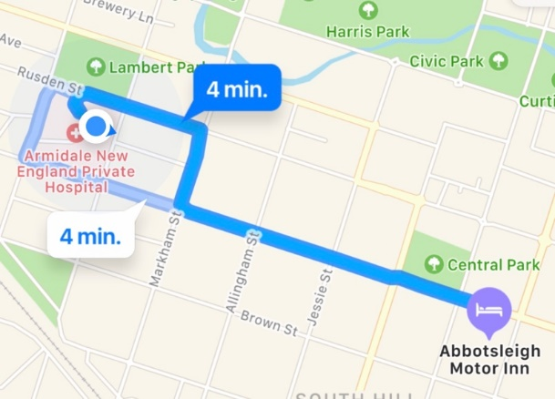
Acacia Motor Inn  192 Miller St  6772 7733 | PRICE LIST  Standard Room - $105  Double Room-$130  Twin Room - $150  Double Room (Disability Access) - $155  Family Room - $185- 5 people  $15 per extra person | 2.2km’s  5 minute drive from the Hospital | 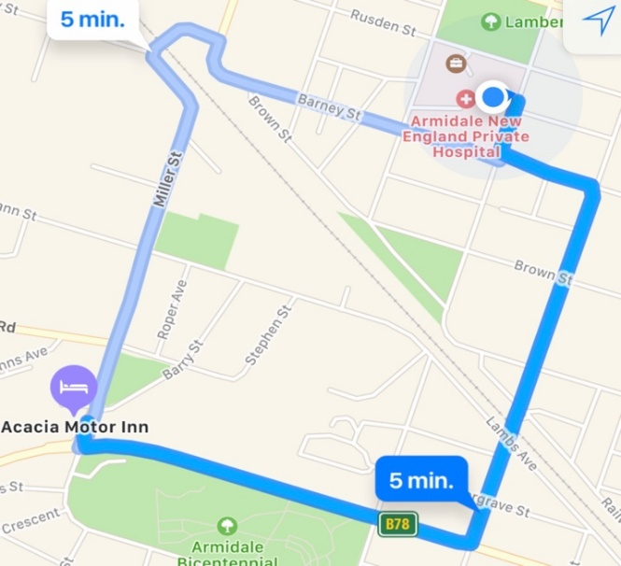
Alluna Motel  180 Dangar St  6772 6226 | PRICE LIST  Budget - $100  Twin Share- $125  Family Rooms $145-4 people  $150- 5 people $155- 6 people  Extra bed $10 | 1.8  5 minute drive from the Hospital | 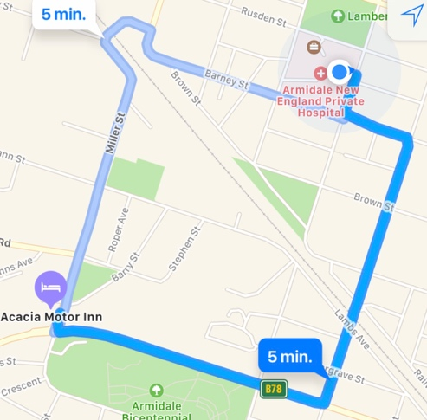
Armidale Acres Motor Inn  11294 New England Hwy  6771 1281 | PRICE LIST  Deluxe apartments: Single - $103  Double - $107  Twin Share - $113  Cabins and vans available from$40 | 7.5km’s  10 minute drive from the Hospital | 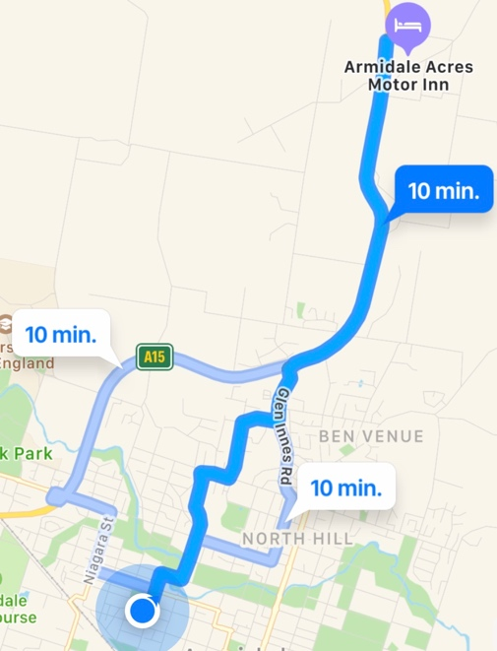
Armidale Motel  66 Glen Innes Rd  6772 8122 | PRICE LIST  Studio room - $105  Family Suite- $190 for 7 people  Twin and executive rooms available  Pet Friendly | 3.3km’s  7 minute drive from the Hospital | 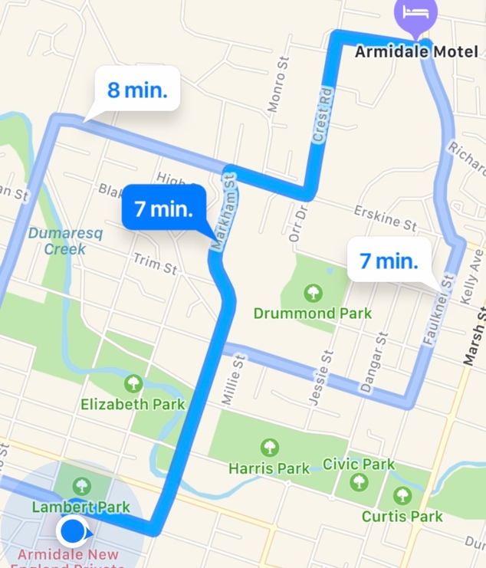
All Seasons Motel  208 Dangar St  6772 9800 | PRICE LIST  Queen - $125-159  Twin Share - $135-169  Family Room - $159-189  Special Hospital Rates depending on month of stay. Discounted price for a stay over three nights | 2km’s  5 minute drive from the Hospital | 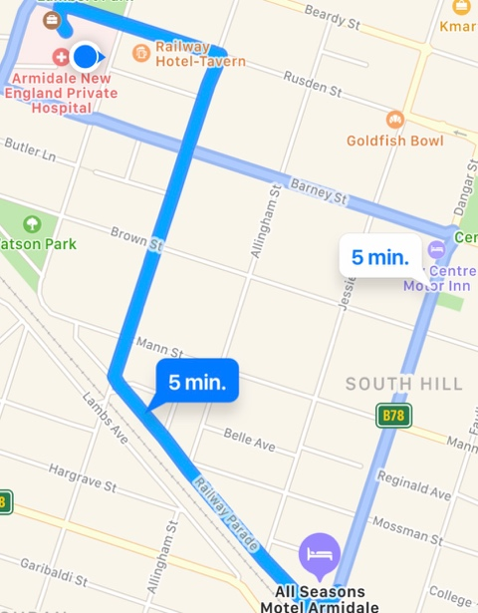
City Centre Motor Inn  Cnr Dangar  St & Barney St  6772 2351 | PRICE LIST  Queen - $130  Twin Share - $130  Family Room - $139  Refurbished Room-$175 | 1.4km  5 minute drive from the Hospital | 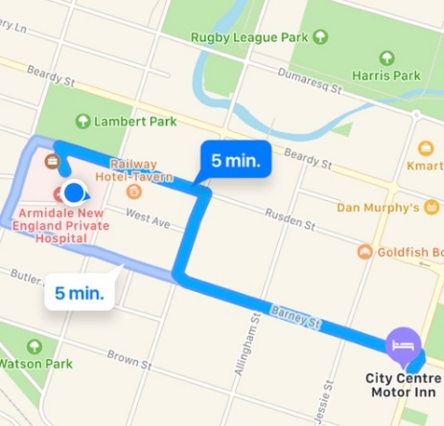
Cedar Lodge  119 Barney St  6772 9511 | PRICE LIST  Queen - $110  Deluxe Room- $120  Family Room - $145-175 | 1.6km’s  5 minute drive from the Hospital | 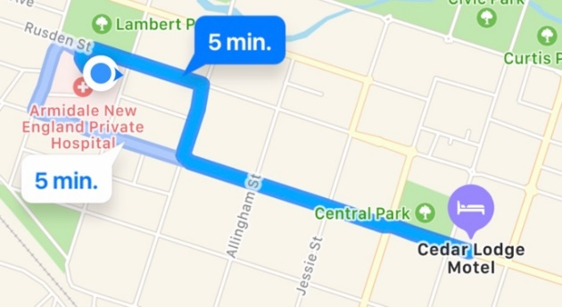
Country Comfort  86 Barney St  6772 8511 | PRICE LIST  Standard - $109-115  Twin Share sleeps 3: $119-125 | 1.5km’s  6 minute drive from the Hospital | 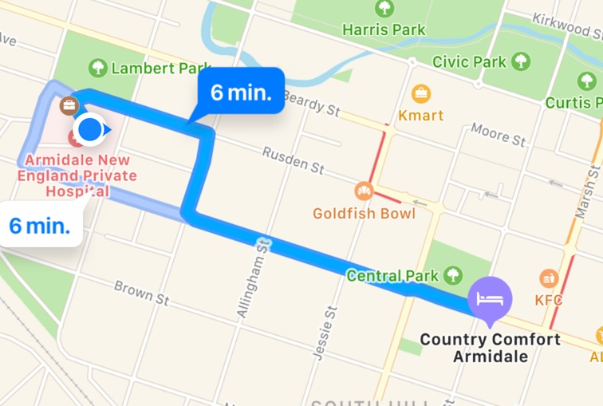
Deer Park Motor Inn  72-74 Glen Innes Rd  6772 9999 | PRICE LIST  Queen - $119  Twin Share - $139  Family Room - $164  Pensioner Rates Available | 3.7km’s  7 minute drive from the Hospital | 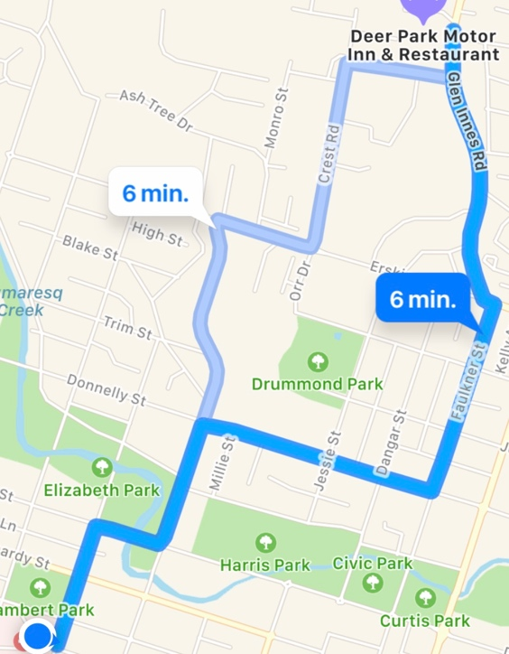
Estelle Kramer Motor Inn  70 Glen Innes Rd  6772 5200 | PRICE LIST  Queen - $115  Twin Share - $125  Family Room- $160  Apartment – from $180 | 1.6kms  5 minute drive from the Hospital | 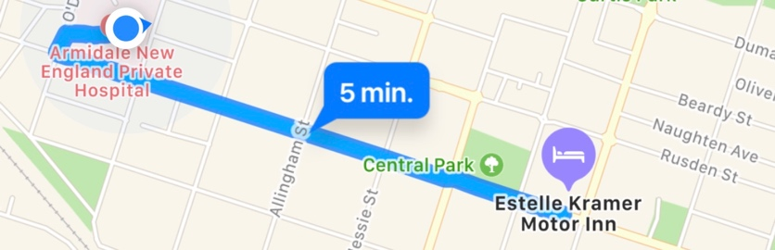
Elite Motor Inn  71 Marsh St  6771 5377 | PRICE LIST  Queen - $125  Twin Share- $140  Family Room - $180  Queen & 2x singles all in the one room- $156 | 1.5km’s  5 minute drive from the Hospital | 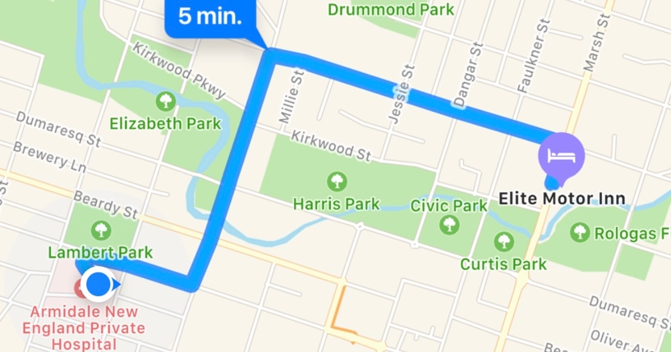
The Royal Hotel  Marsh St  6772 1444 | PRICE LIST  Rooms from $85 | 1.7km’s  6 minute drive from the Hospital | 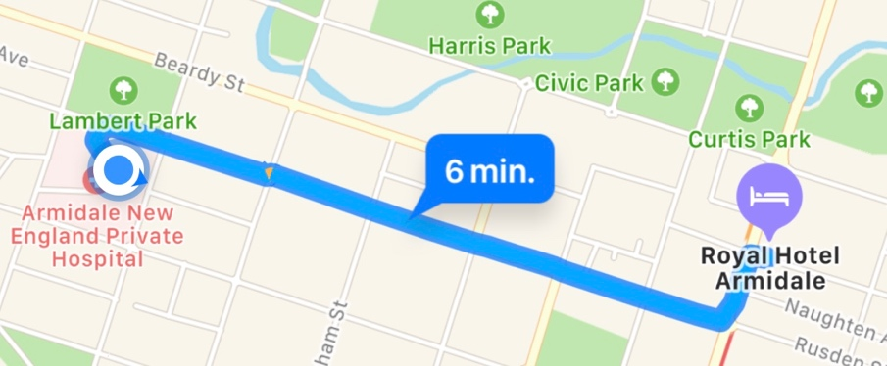
The St Kilda Hotel  104 Rusden St  6772 4459 | PRICE LIST  Rooms from  $35 a night  $150 a week | 1.6km’s  6 minute drive from the Hospital | 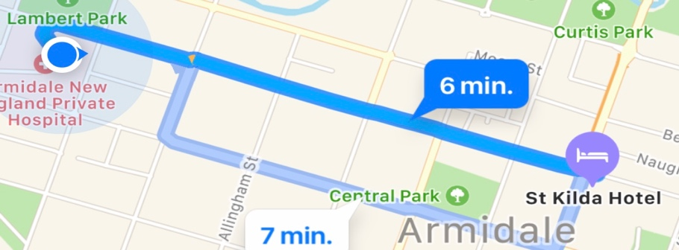
The Quality Hotel Powerhouse  31 Marsh St  6773 7200 | PRICE LIST  Bed & Breakfast - $227 Queen - $199  Family Room - $269  Cottage - $550 | 2.6km’s  6 minute drive from the Hospital | 