Information Pack for Visitors to the John Hunter Hospital

John Hunter Hospital

2 Lookout Rd, New Lambton Heights

NSW 2305

Ph: (02) 4921 3000

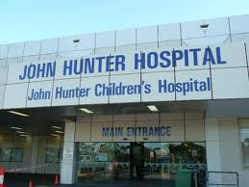

# 

# Social Work Department

# John Hunter Hospital

Enclosed is information that may be helpful for patients and families who are coming to John Hunter Hospital, John Hunter Children’s Hospital and / or the Royal Newcastle Centre from out of area and are not familiar with the John Hunter Hospital or the surrounding local area. The pack includes information about services and facilities that may be useful during your time at the John Hunter Hospital.

If you would like to speak to a social worker whilst you are in the hospital please ask a member of the ward staff to page a social worker or ask at the information desk at the front foyer of the hospital entry.

Kind Regards

Social Work Department

John Hunter Hospital

Hunter New England Health District

ABN 63 598 010 203

Social Work Department, John Hunter Hospital

Lookout Road, New Lambton Heights NSW 2305

Tel 02 4921 3700 Fax 02 4921 3704

Website www.hnehealth.nsw.gov.au

Contents

Important Information…………………………………………………………………..p4-7

Smoke free site

Parking

Visiting hours

Isolated Patients Transport and Accommodation Scheme (IPTAAS)

Aboriginal Hospital Liaison officer & Social Work

Inpatient Laundry service

Hospital Facilities/ Services………………………………….……….………………p8-15

Food Outlets/Eateries

Spiritual

Family and Children’s Facilities

Stores/Outlets

Medical Services

Banks and ATMs

Onsite Accommodation……………………………………………………………….p16

Alternative Accommodation……………………………………………………..…p18

Transport……………………………………………………………..……………………..p19

Shopping Centres………………………………………………….…….……………….p21

Post Offices, Pharmacies and Banks …………………….………………………p23

Local Food Venues……………………………………………………………………….p25

Feedback Form………………………………………………………………………….…p27

Important information about the John Hunter Hospital

# Smoking free site

John Hunter Hospital is committed to protecting staff, patients and visitors from the harmful effects of tobacco smoke. The John Hunter Hospital is therefore a smoke free site. This means you cannot smoke in any buildings, grounds, vehicles or car parks. If you are a patient and are having difficulty managing cigarette cravings please inform nurses.

# Parking at the John Hunter Hospital

# 

Visitor parking fees

|  |  |  |
| --- | --- | --- |
| ***Time*** | ***General*** | ***Concession & Disabled*** |
| Less than 20 minute | Free | Free |
| 20mins-1hr | $2.50 | $2.50 |
| 1-2 hrs. | $5.00 | $3.50 |
| 2-3 hrs. | $7.50 | $5.00 |
| 3-4 hrs. | $10.00 | $6.00 |
| 4-5 hrs. | $10.00 | $7.00 |
| 5hrs and over | $10.00 | $8.00 |
| Weekly pass* | $25.00 | $25.00 |
| Note: If your car has been left in the car park for several days you will only be charged a maximum of $10.00  *Purchase at ticket booth. Prices current as of 6/9/2013. | | |

* If you are experiencing financial difficulty please arrange to speak with the ward social worker at the John Hunter Hospital.
* People staying on site in the cottage accommodation will be given a swipe card that gives them access to parking free of charge.
* Patients with private health insurance and Department of Veterans Affairs patients who are admitted to hospital may obtain 2 free parking vouchers from the admissions desk.

# Offsite Parking

Free off-site parking is available at Hunter Stadium (294 Turton Road, Broadmeadow), with a free shuttle bus service direct to John Hunter Hospital. The shuttle bus runs from 9am-4:30pm Monday to Friday. During these hours the shuttles do one round trip, taking people to and from John Hunter Hospital and Hunter Stadium every 40 minutes.

# Visiting hours

Visiting hours vary from ward to ward:

* In the maternity wards visiting hours are 3pm-8pm, with the exception of the father/partner who can also visit from 10am in the morning. Rest time for mums and babies is from 1pm -3pm.
* John Hunter Children's Hospital: Parents / guardians are allowed any time on the wards. Other visitors are welcome between 10:00am-1:00pm and 3:00pm-7:00pm. Children's rest time is between 1:00pm-3:00pm. Please note only 1 x parent / guardian is allowed to stay overnight on ward with child.
* Neonatal Intensive Care Unit: Parents/guardians are allowed any time. Visitors are admitted at the discretion of families and staff. Babies rest time between 1:00pm-3:00pm.
* Adult Wards: Standard ward visiting hours are 11am-1pm and 3pm-8pm.
* ICU: Family allowed any time. Visitors are allowed at the discretion of families and staff. All visitors must speak with staff upon arrival to the unit before entering. Only 2 visitors allowed at any time.
* Paediatric ICU: Parents/guardians allowed any time. Visitors are admitted at the discretion of families and staff. All visitors must speak with staff upon arrival to the ward before front doors will be opened for entry.

# Isolated Patients Travel and Accommodation Scheme (IPTAAS)

IPTAAS is a subsidy program which provides financial assistance to help with the costs of travel and accommodation for people (and eligible escorts) who need to travel long distances to access specialist treatment not available locally. Patients travelling at least 100km each way, or at least 200km per week cumulative distance, are eligible to apply for IPTAAS subsidies. Discuss further with the ward Social Worker or the Aboriginal Hospital Liaison Officer, see application form pg. 18 for information on how to apply.

# Aboriginal Hospital Liaison Officer

There is an Aboriginal Hospital Liaison Officer (AHLO) available from Monday – Friday between 9am – 5pm. To contact the AHLO please ask the ward clerk or the information desk to page her on pager no 2116. The AHLO receives a list of hospital patients who identify as Aboriginal and Torres Strait Islander but is not usually be able to see all inpatients as a matter of course because she covers all JHH, JHCH and RNC as well as Outpatient clinics. Therefore it is important to ask to speak to the AHLO and not just wait till you happen to see her on the ward.

The AHLO can help you with cultural support and information, options for accommodation and assistance with IPTAAS and making your concerns or special needs known to ward and treating staff.

We encourage all Aboriginal and Torres Strait Islander patients to identify and “Speak Up”. We value the thoughts and opinions of our Indigenous community members and are working hard to ensure that this hospital and our staff are welcoming and a respectful place to come and receive treatment.

# Social Work Service

Social Workers are available at the John Hunter Hospital, John Hunter Children’s Hospital and Royal Newcastle Centre on all inpatient wards during business hours on weekdays. Staff in the Social Work Department provide a wide range of services to patients including support, advocacy, adjustment to illness and/or treatment, assessment, discharge planning and referral to services. Refer by requesting on ward (Mon – Sun) or Ph: 49213700 (Mon – Fri). A Social Work service is also provided after hours, seven days per week and on the weekends. It is important to note that this is a limited service with only one social worker covering all wards of the hospital. This service is specifically aimed to provide support to patients and their families in the event of crisis situations. If you feel that you need urgent social work assistance during these hours, please advise the nurse caring for you or your family member. But please note some requests may be unable to be attended to on the same day as day of referral and may need to wait till the following day or if referred on a weekend may need to wait until Monday.

# Inpatient Laundry Service

Volunteers provide an inpatient laundry service for patients who do not have any family support or are not from this local area. Laundry can be collected from 7:30am to 11:00am Monday to Friday. For service to your ward please contact the volunteer workroom on 492 23007.

John Hunter Hospital facilities

* The John Hunter Hospital is a large tertiary hospital with over 600 beds, encompassing John Hunter Hospital, John Hunter Children’s Hospital and the Royal Newcastle Centre.
* The John Hunter Hospital is a long building with three floors. The main entrance is officially level two; you will find most of the facilities on this level including the Information Desk and Security office.
* The Security department is located in the main entrance to the hospital, on the right side. If you have to walk to your car late at night or if at any time you feel your safety is compromised please access the Security department staff who are able to walk or drive you to your car if your car is on hospital grounds.

Ward Layout John Hunter Hospital

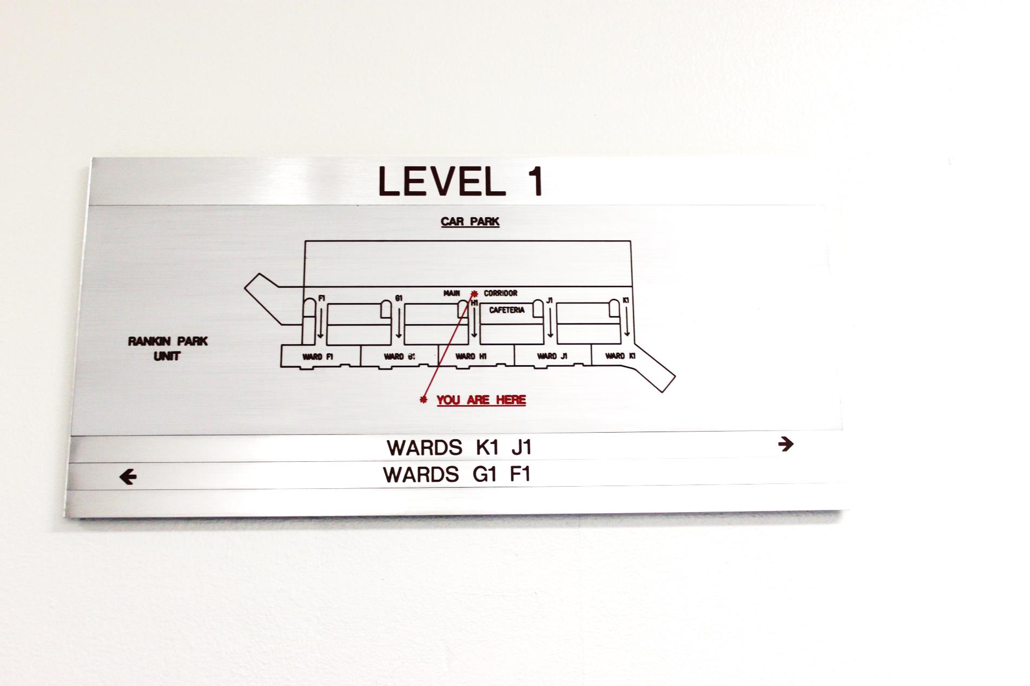

K1 Nephrology/Dialysis

J1 Paediatric Surgery/ Paediatric Oncology

H1 Children’s Medicine

G1 General Surgery

F1 Orthopaedics

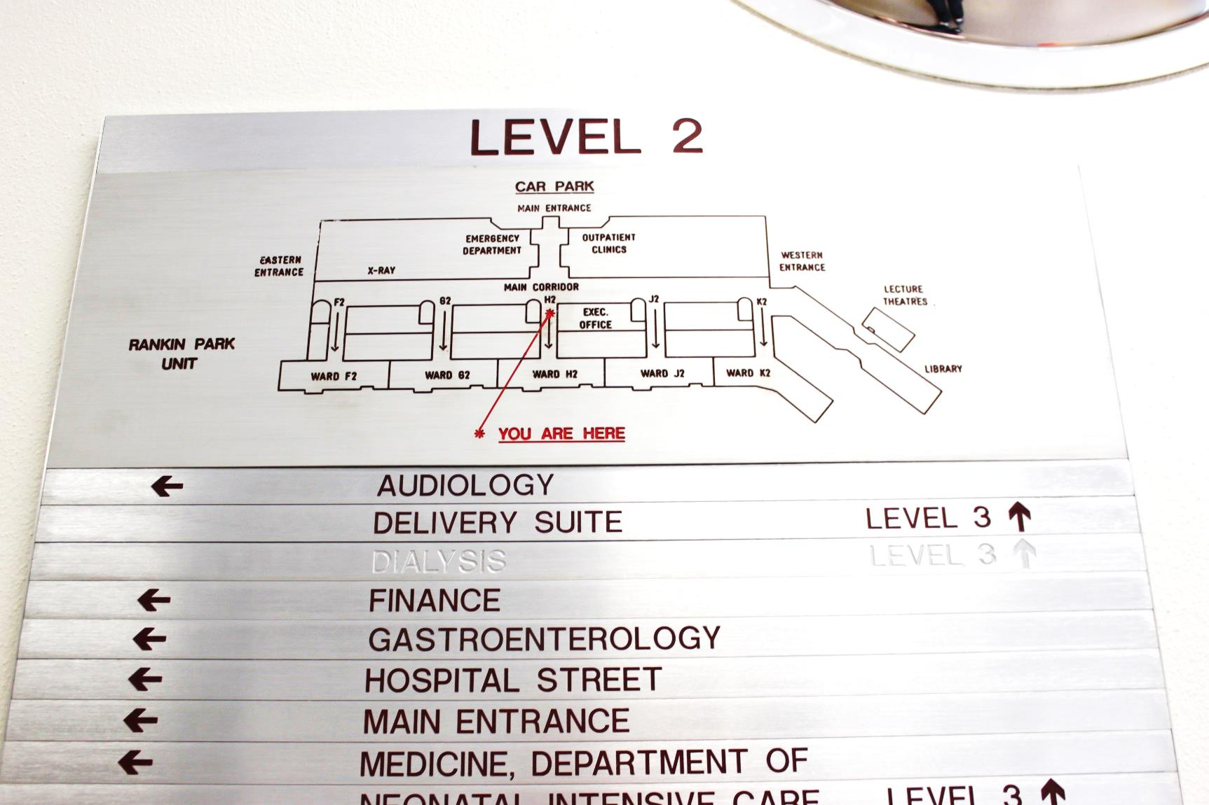

Adult & Paediatric Emergency Room; Emergency Department

The Nexus Unit; Adolescent Mental Health

K2 Post Natal Acute

J2 Adolescent/ Paediatric Day Stay

H2 Emergency Short Stay Unit/

Medical Assessment Coordination Unit/ CAPAC

G2 Acute Stroke Unit/ Neurology & Neurosurgery

F2 Respiratory/ Clinical Immunology

***Special Notes re Ward stay for Maternity Patients:***

*Maternity Services and Gynaecology advise that the average length of stay for women who deliver a baby vaginally is 2 – 3 days and via Caesarean section 4 – 5 days.*

*Women who are medically well following the birth of their baby can expect to be discharged from hospital in line with these timeframes. There is no provision for women to stay in a hospital bed, post these timeframes, even if their baby is being cared for in the NICU.*

*If these circumstances arise, women and their partners / families will need to think about alternative accommodation plans if they wish to remain close to the NICU. Timely discussion with* the Social Workers from either Maternity Services or the NICU is advised.

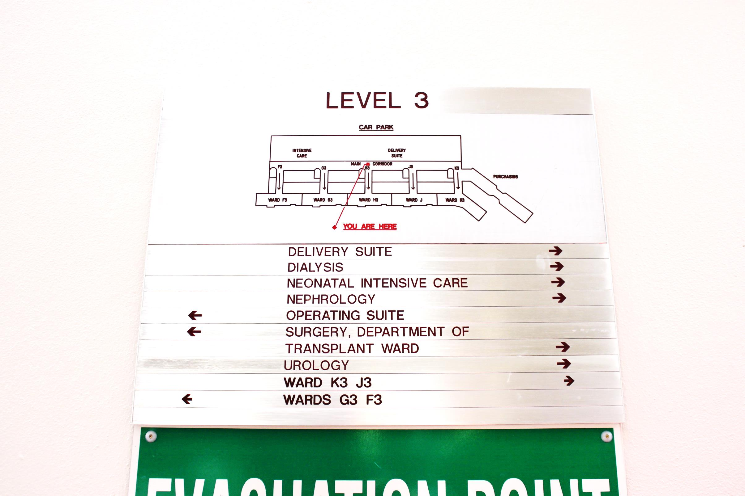

Coronary Care Unit

Delivery Suite/ Birth Centre

Intensive Care Unit

Neonatal Intensive Care Unit

Operating Theatre

Renal Transplant

K3 Hunter Centre for Gynaecology cancer/ Gynaecology /Antenatal

J3 General Medicine

H3 Otolaryngology/ Head & Neck Surgery/ Maxio-facial Surgery &Trauma

G3 Gastroenterology/Cardiology

F3 Vascular Surgery/ Cardiac Thoracic Surgery

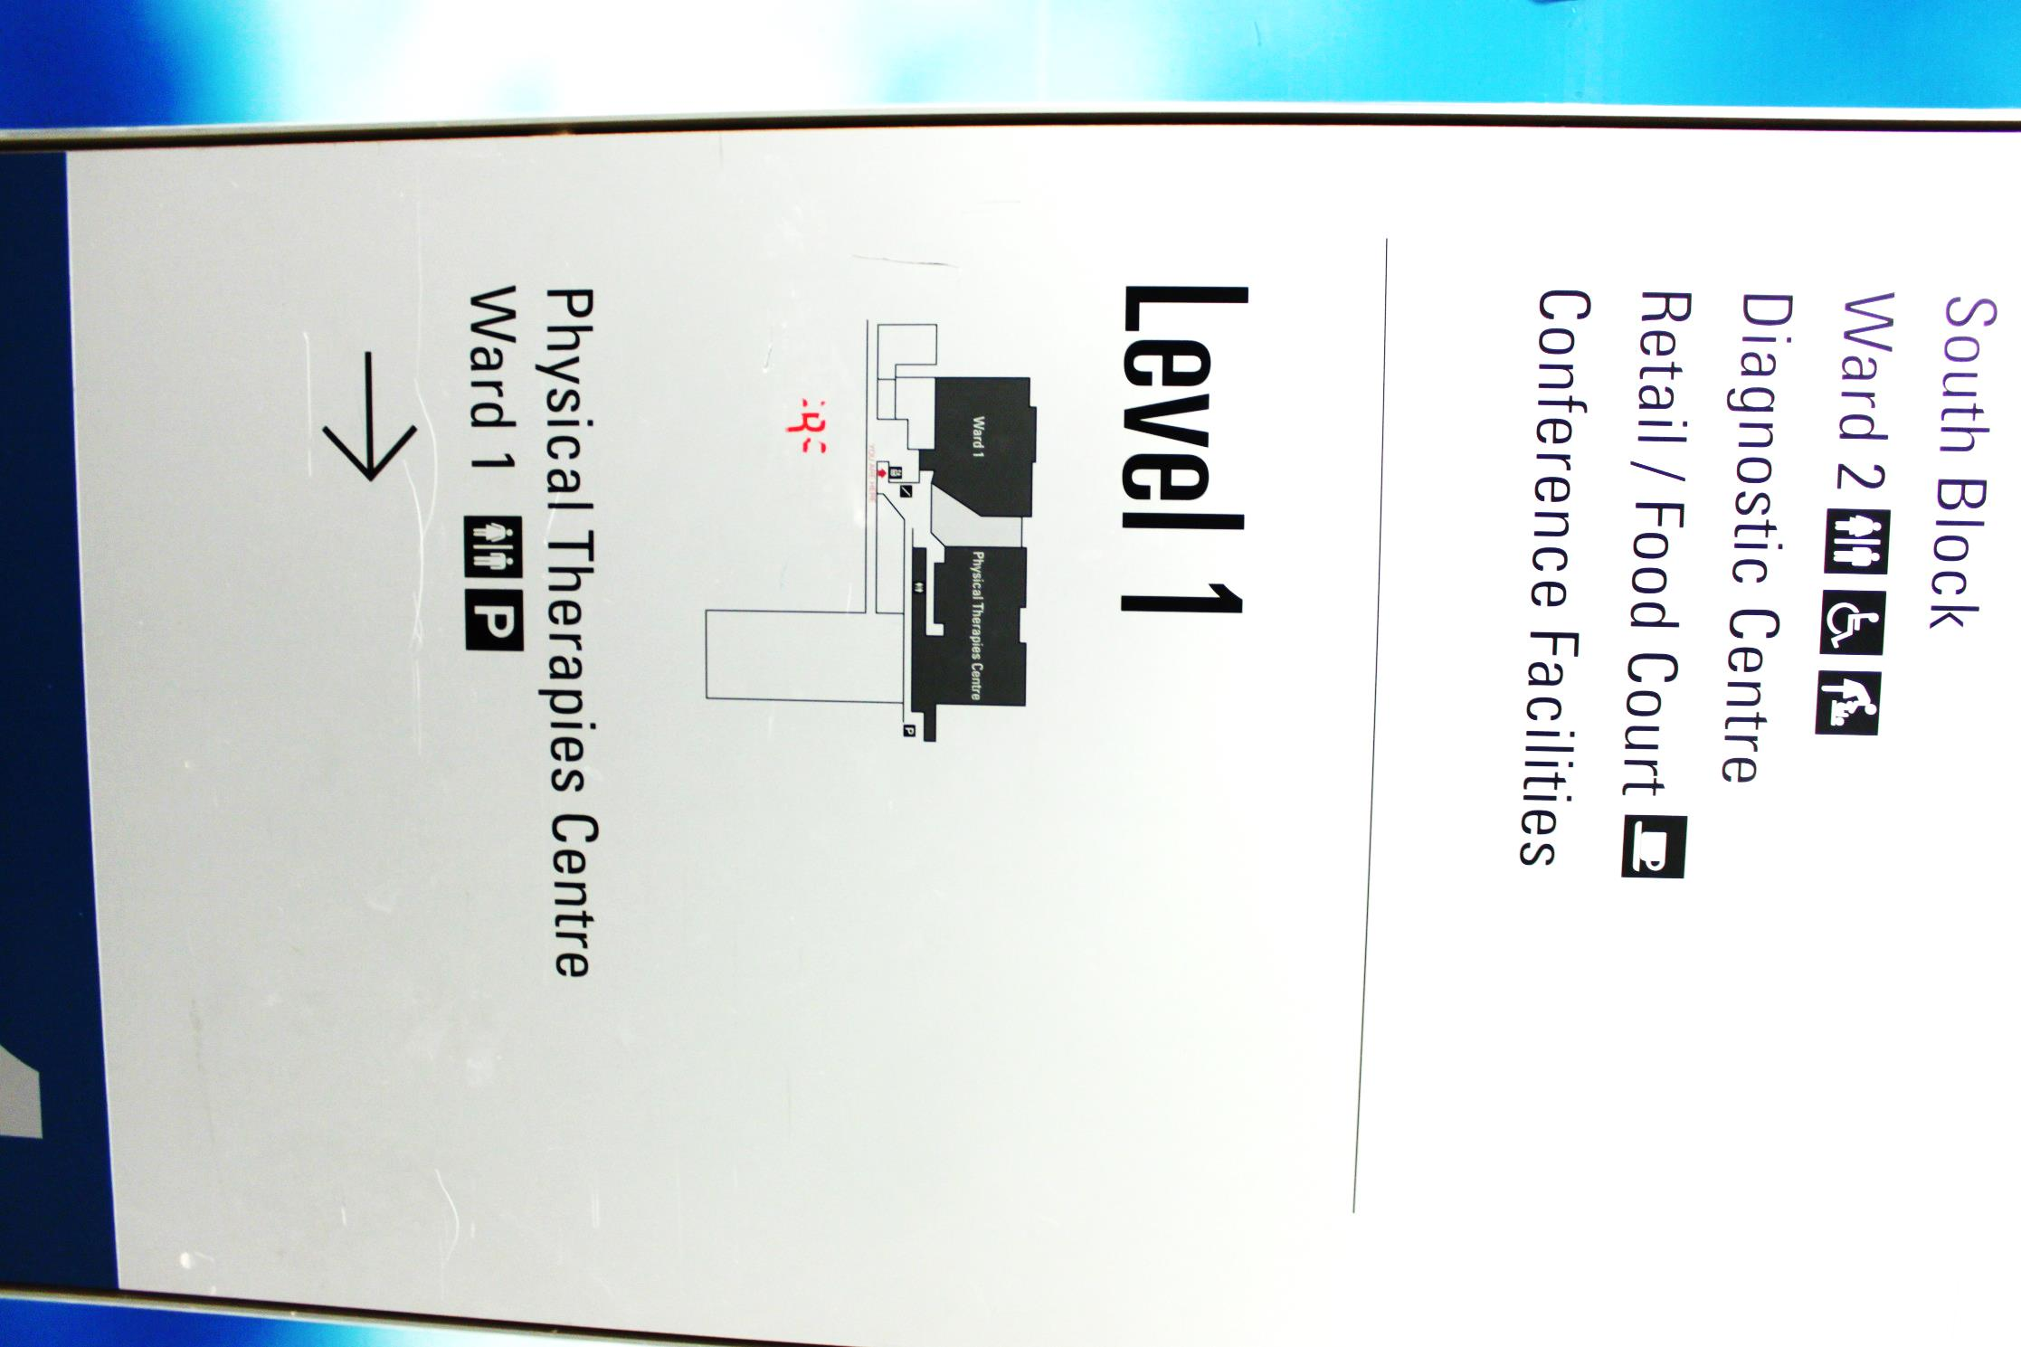**Royal Newcastle Centre Ward/ Facility Layout**

**Level 1**

Physical Therapies Centre

Ward 1: Orthopaedics Rehabilitation

# Level 2

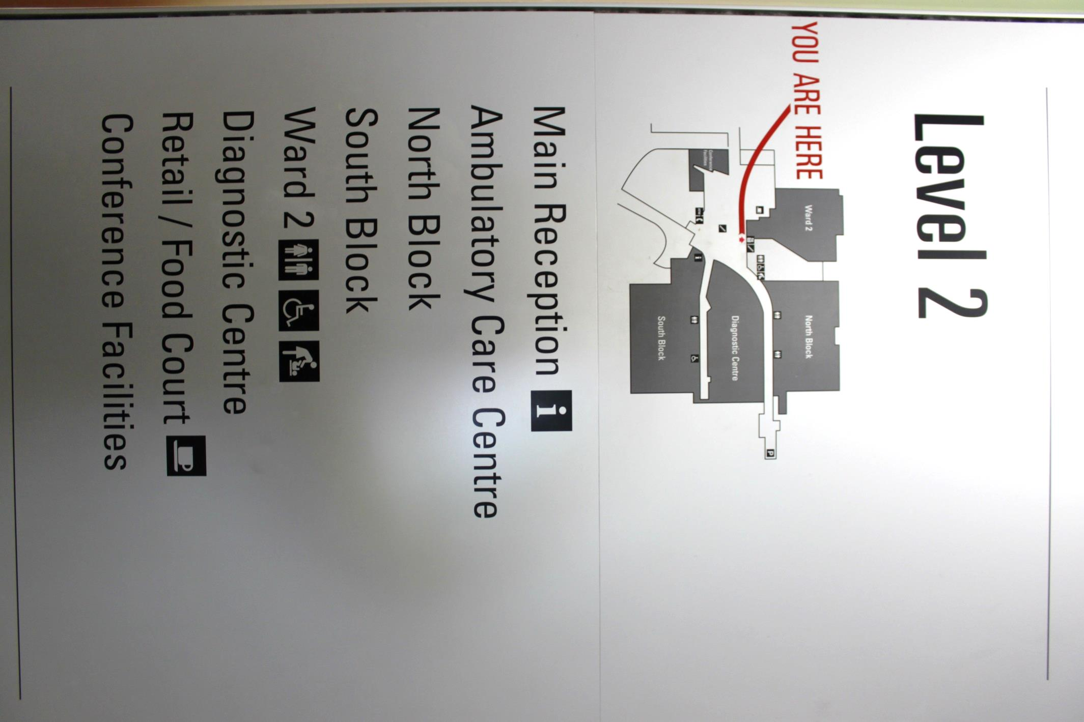Main Reception

Ambulatory Care Centre

Ward 2: Rheumatology/ Urology

Diagnostic Centre

Retail/Food Court

Conference Facilities

# Level 2 - Cont.

North Block: Outpatient Clinics including : Cardiology Meds, Dermatology, Diabetic Services, Drug & Alcohol Services, Endocrinology, Gastroenterology, General Medicine, Geriatric Medicine, Immunology and Infectious Diseases, Liver Diseases, Nephrology, Neurology, Rehabilitation Medicine, Respiratory , Rheumatology

South Block: Outpatient Clinics including: Ambulatory Care Centre, Vascular Surgery, Neurology, Renal Surgery and Transplant, Pre-Operative Assessment, Pain Management, Ear, Nose and Throat, Vascular Disease Prevention, Cardio Thoracic Surgery, Colo- Rectal Surgery, General Surgery, Neurological Surgery, Ophthalmology , Oral and Facio Maxillary, Orthopaedics and Rehabilitation.

# Level 3

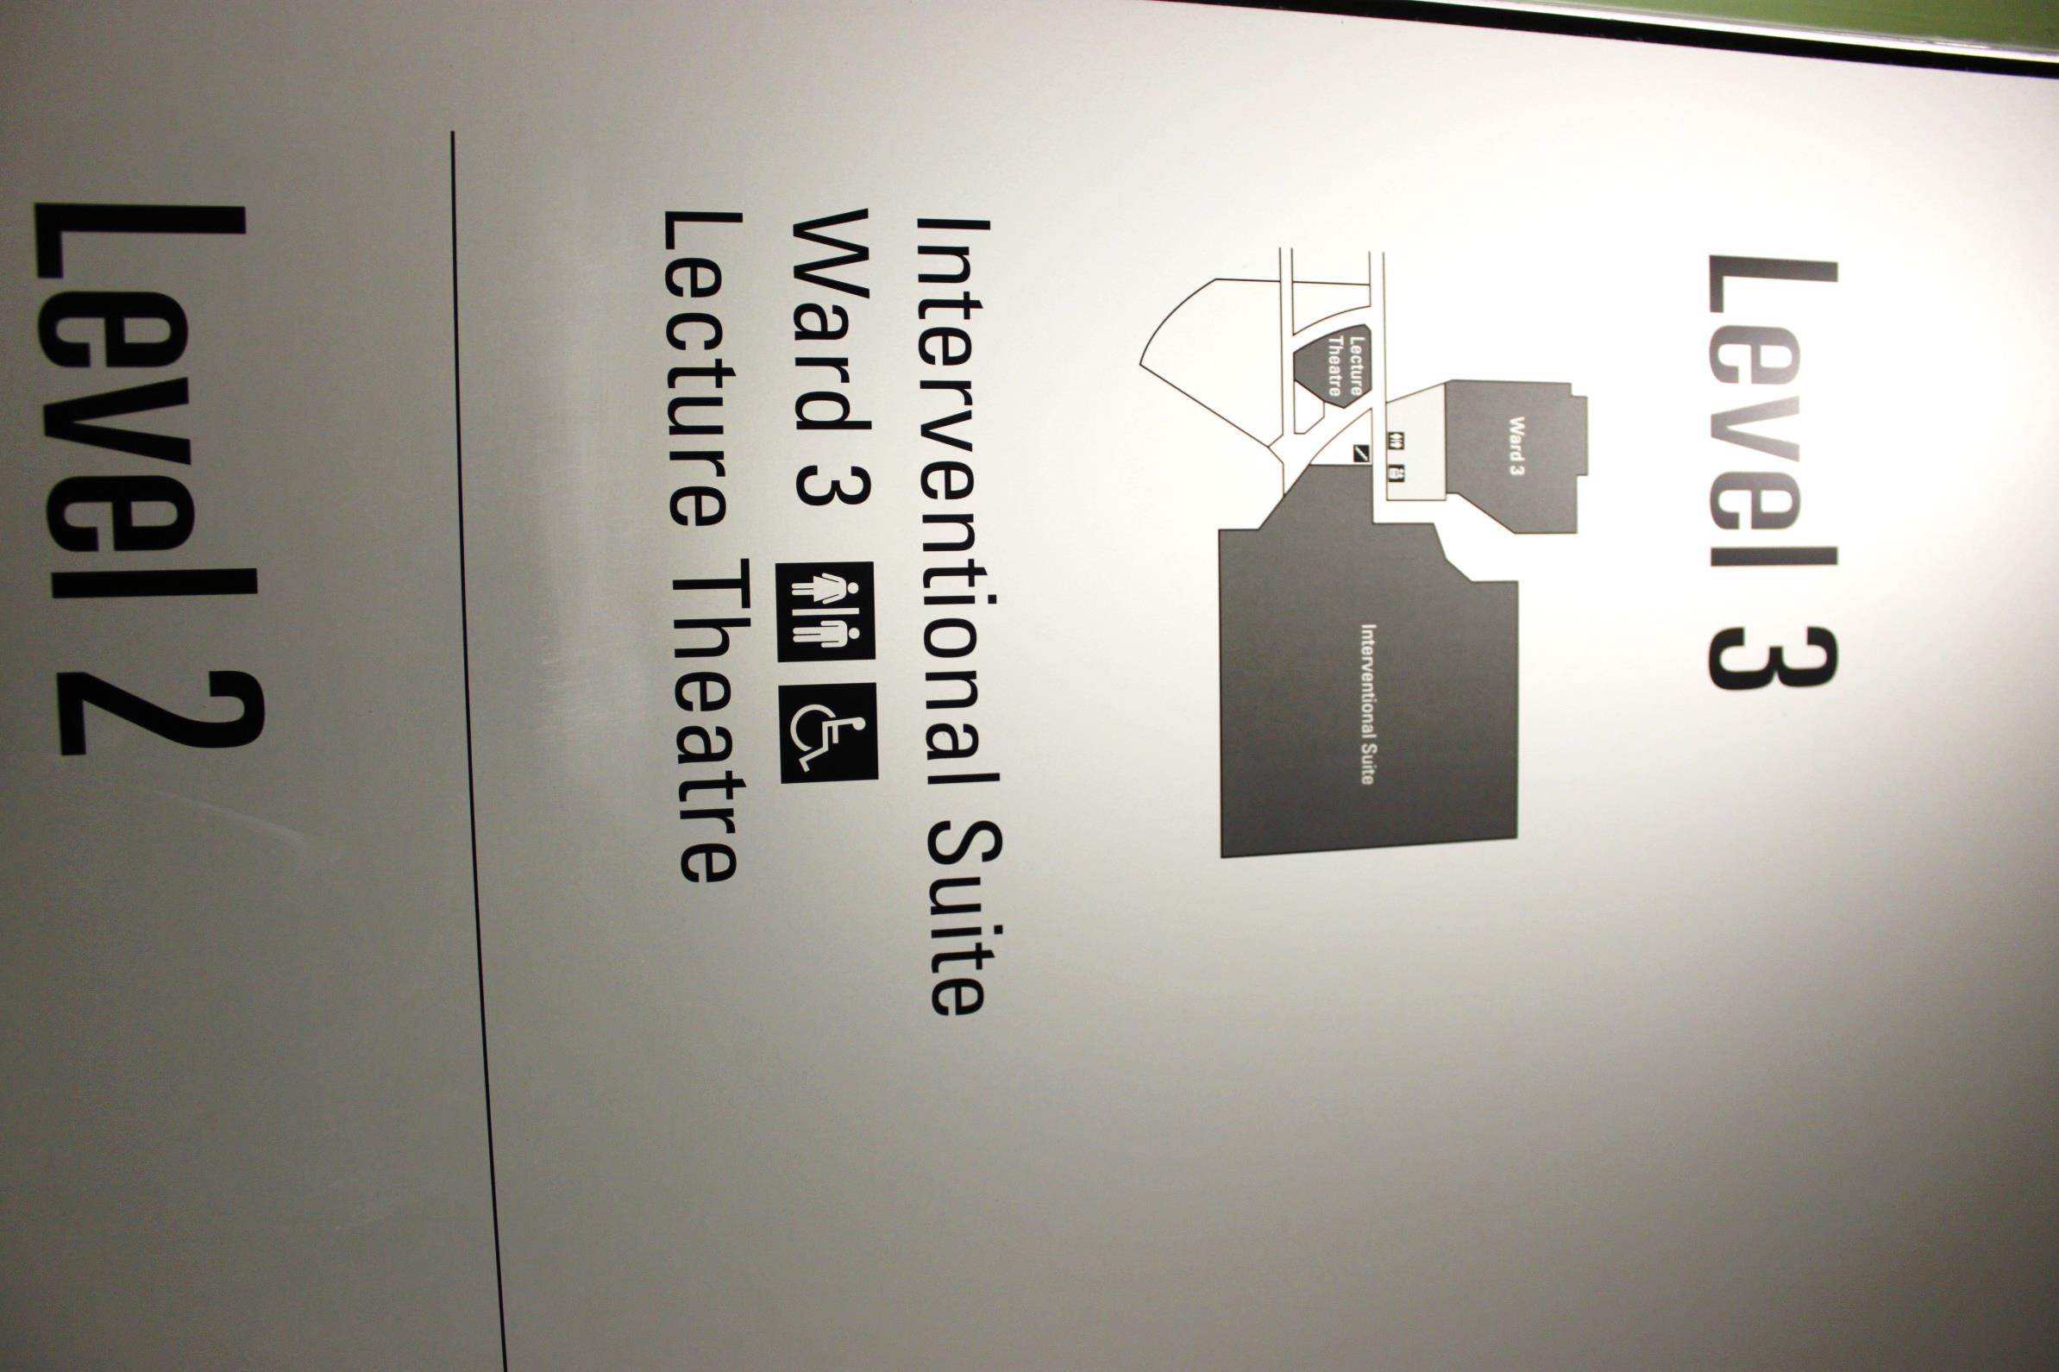Interventional Suite

Ward 3

Lecture Theatre

|  |
| --- |
| Food Outlets/ Eateries **Café**  Grab and Go Go  7am-8pm Monday to Friday  9am- 9pm Saturday to Sunday  Located near Emergency Department/entrance of hospital, on level 2.  **Café**  Baratza  8am-3:30pm Monday to Sunday.  Located near K2/Nexus on level 2.  **Café**  Baratza  7am-7:30pm Monday to Sunday.  Located in the Royal Newcastle Centre Foyer, level 2.  **Cafeteria**  Cosy Kookaburra Cafeteria  7am-6:30pm Daily.  Dinning hours: 11:30am-1:45pm and 4:30pm-6:30pm.  Located between H and J Block, level 1.  **Cafeteria**  Central  7am-7pm Monday to Friday, 11am-7pm Saturday to Sunday.  Located in the Royal Newcastle Centre Foyer, level 2.  **Salad Bar and Juices**  Wrap it Up  9am-4pm Monday to Sunday.  Located in the Royal Newcastle Centre Foyer, level 2. Spiritual **Chapel**  The hospital is Chapel located in the front foyer of the hospital. Spiritual support is available 24 hours a day. At your request pastoral staff can contact a Rabbi, Imam, Minister or Priest or religious leader of your faith.  **Meditation room**  A meditation room with washing facilities is located on level 3, Royal Newcastle Centre. Family and Children’s Facilities **Fairy Garden/ outdoor playground**  Exit door on left when entering ward J1  **Ronald McDonald Family Room**  Kitchen facilities, TV/lounge area, children’s toys, shower facilities, rest room and laundry. Open Monday to Friday 8am-9pm.  Saturday to Sunday 9am-6pm.  **Starlight Room**  Monday to Friday 10:30am-3:30pm. Closed Sat and Sun.  Craft, movies and other activities. Stores/ Outlets **Newsagency**  7am-7pm Monday to Friday 9am- 4pm Saturday to Sunday  Located on level 2, in front foyer.  **KC Gift shop**  8am-4pm Monday to Friday  9am-2:30pm Saturday and Sunday. Located on level 2, front foyer.  **Florist**  Lavish  9am-5:30pm Monday to Friday 9am-3pm Saturday to Sunday  Located level 2, between H and G block. Medical services **GP Access**  After hours Ph: 1300 130 147  Monday-Friday 6pm-8am  Saturday 1pm-Monday 8am.  GP Access After Hours provides after hours medical care. Visiting families from out of area often use if they require scripts or feel unwell. Located near hospitals front entrance, to the left of the information desk.  **Docs Pharmacy**  8:30am-9pm Monday to Friday  1pm-9pm Saturday  10am-9pm Sunday  Located in the Royal Newcastle Centre level 2.  **CareQuip**  Located within Docs pharmacy, equipment to assist with mobility & daily living available for purchase. Banks and ATMs Newcastle Permanent Building Society, in foyer area of Royal Newcastle Centre Building, level 2.  Newcastle Permanent ATM, near information desk/ front entrance to JHH hospital, level 2. |

Onsite Accommodation

|  |  |  |  |
| --- | --- | --- | --- |
| Kookaburra Cottage** | **Onsite John Hunter Hospital** accommodation comprises of 2 cottages with a total of 13 rooms.  Each room has 2 single beds, with the exception of 1 room that has 2 double beds.  Please note only one room per family per patient can be provided due to large number of patients being transferred to JHH from out of area for specialised treatment. | $30 per person | Booked through KC Gift shop  Ph: 49213650 |
| Uncle Bobs Yallarwah for Indigenous and Torres Strait Islander people** | **Onsite John Hunter Hospital**, 6 rooms total. Each room has two single beds, with the exception of one room which has two double beds. | $33 per room | Booked through KC gift shop  Ph: 49213650 |
| Hanka House - dialysis & transplant patients family | **1a Dudley Rd, Charlestown**,  4 rooms. | From $43 | Ph: 49048800  re vacancies & bookings |
| John Hunter Bed & Breakfast | **61A Lookout Rd,**  **New Lambton Heights** | From $90 | Ph: 0430226500 |
| Ronald McDonald House | **Onsite John Hunter Hospital**. Eligible to families who have a child patient under age of 18 years who live more than 100kms from JHH.  Accommodation comprises of 18 rooms, including 6 x self-contained villas where children require isolation and 12 rooms with at minimum 2x single beds and at most 2x double beds and 4 x single beds. The latter 12x rooms have T.V, DVD and bathrooms facilities and shared kitchen, laundry, play room, games room and common room.  Please note only one room can be provided per patient’s family.  Porta-cots and fold out beds can be added to rooms to accommodate needs. | $43 per night if child is an inpatient.  $60 per night if child is staying in the house as an outpatient. For more than 3x night’s accommodation can be bulk billed through IPTAAS. | Ph: 49214733  re vacancies & bookings. |

*For any concerns about the cost of accommodation, arrange to speak with the House Manager at the time of booking or upon arrival, or speak with your Social Worker at the John Hunter Hospital / John Hunter Children’s Hospital.

**Priority is given to people who have travelled over 100km to the John Hunter Hospital campus. IPTAAS may be able to assist with either reimbursement or payment of accommodation costs if staying for more than 3 days. If you are staying in onsite accommodation you will receive a swipe card giving you free access to the car park.

**Alternative Accommodation Suggestions**

Inform providers you have been referred by the John Hunter Hospital as discount prices may apply. Prices listed are starting prices only and weekend rates are not included. All accommodation is accessible from John Hunter Hospital by bus. Bus timetables are available at information desk or call 131 500 for information on times, bus routes and prices.

|  |  |  |  |  |
| --- | --- | --- | --- | --- |
| Name of Accommodation | Address | Prices starting at | Distance from JHH | Phone number |
| IBIS (Budget) Hotel | 3-5 Thomas St, (corner of Link and Lakes Rd. Wallsend exit F3 Freeway) Wallsend | $69 | 6km | 49 500 244 |
| General Roberts Hotel | 258 Lambton Rd,  New Lambton | $40 | 2km | 49 571 818 |
| Northern Star Hotel | 112 Beaumont St, Hamilton | $40 | 5km | 49 611 087 |
| Serenity Bed & Coffee | 10 Kuranda Cres, Kotara  96 Russell Rd, New Lambton | $99 | 5km  2km | 1300662021 |
| The Mark Hotel | 46 Dickson St, Lambton | $55 | 2km | 49 527223 |
| West Executive Inn | 10 Rugby Rd,  New Lambton | $160 | 2km | 49 351 100 |
| Apollo International Hotel | 290 Pacific Hwy, Charlestown | $135 | 7km | 49 436 733 |
| Mecure Charlestown | 109 Madison Dr, Charlestown | $125 | 7km | 49 438 899 |
| Blue Gum Apartments | 181 Michael St, Jesmond | $120 | 4km | 49 614342 |
| Panorama Motor Inn | 256 Pacific Hwy, Charlestown | $105 | 7km | 49 433 144 |
| Adamstown Elizabeth Motor Inn | 165 Brunker Rd, Adamstown | $120 | 4km | 49 527 111 |
| Tudor Motor Inn | Corner Tudor and  Steel St Hamilton | $130 | 5km | 49 692 533 |
| Cardiff Motor Inn | 15 Muningbung Rd, Cardiff | $120 | 7km | 49 546 738 |

**Transport**

* Contact the Transport Information Line re times and routes for local buses and trains. Phone: 131500
* Contact NSW Trainlink (formerly Country Link Number) for timetables and bookings for trains out of the local area. Phone: 132232
* Newcastle Taxis: 133 300 or free call from red phone near security office/entrance of hospital.

*Note: See* ***Shopping Centres Section*** *for local shopping centre bus routes*

|  |
| --- |
| **Broadmeadow Station**  ***Address****:* Graham Road, Broadmeadow  ***Telephone****:* 4962 9122  Take bus 363 or 222 depending on day/time.  Both buses follow the route below and take approximately 22 minutes to reach destination.   * Walk to bus stop directly out the front of the main entrance of John Hunter Hospital. * Depart John Hunter Hospital. Get off the bus at Lambton Road near Market Street, Broadmeadow * Walk to Broadmeadow Station.   + Walk north down market street.   + Turn left into Young Road.   + Walk to end of Young Road and train station will be directly in front of you. (Approximately 3 mins walk.)   Taxi fare in peak hour approximately $20.  During week days, you can also take a taxi from the Station to Ausgrid Stadium and be brought to the campus by the free shuttle bus, (information provided previously in this document) which will cost less.  **Newcastle Station**  **Address:** Scott Street, Newcastle.  **Telephone**: 4962 9696  Take bus 363 or 222 depending on day/time.  Both buses follow the route below and take approximately 35 minutes to reach destination.   * Walk to bus stop directly out the front of the main entrance of John Hunter Hospital. * Depart John Hunter Hospital.   Get off the bus at Scott Street.  Bus stop is directly out the front of the train station.  Taxi fare in peak hour approximately $30. |

|  |
| --- |
| *Note: All buses listed leave from the main entrance (near ED) of* *John Hunter Hospital* |

**Shopping Centres**

# New Lambton IGA store

***Address:*** Regent St New Lambton 2305

***Public Transport:***Bus Route: 363 (5 minutes)

# Westfield Kotara

**Address:** Corner Northcott Drive & Park Avenue Kotara. 2289.

Shops: *Target, Kmart, Woolworths, Coles, chemist, Australia Post and food court.*

Banks: *Commonwealth, Greater Building Society, NAB, Newcastle Permanent and St George.*

ATM only: *Westpac and ANZ.*

***Public transport:***

Bus 224, 20 minutes

Bus 100 transfer to bus 334 (30 minutes)

# Charlestown square

**Address:** Pearson Street, **Charlestown,** 2290.

Shops: BIG W, Best and Less, Coles, Target, Woolworths, Cotton On, Medicare, chemist, food court and Mega Mania (in door children’s playground)

Banks: Bankwest, Greater Building society and Newcastle Permanent.

**Public Transport:**

Bus 100, 30 minutes

Bus 363 and transfer to 262 (45 minutes)

# Waratah Village

**Address:** Turton Road, Waratah, 2298.

Shops: Coles, Australia Post, Kmart, chemist, Block Buster, Red Roster, Subway, Gloria jeans, food court.

Banks: Newcastle permanent,

ATM only: Companion Credit, Greater Building society and St George.

**Public Transport**:

Bus 100, 45 mins

Bus 222 and transfer to 226 (26 mins).

Both buses leave directly from bus stop outside front doors of John Hunter Hospital.

# Stockland Jesmond

**Address:** 28 Blue Gum Rd, Jesmond, 2299. Shops: Woolworths, Big W, pharmacy, and food court.

**Public Transport:**

Bus 100, 20 mins

Bus 222 and transfer to 260 (36 mins)

|  |  |
| --- | --- |
| Post Offices Post Offices | |
| Lambton 97 Elder Street, Lambton 2299 (02)4957 1547   New Lambton 54 Regent Street, New Lambton 2305  (02)4957 1388 Waratah Shop 9 91 Turton Rd, Waratah 2298  (02)4968 1627 Georgetown 12 Moate Street, Georgetown 2298  (02)4968 2617 | Jesmond Post Shop Shop 42 133 Blue Gum Rd, Jesmond 2299 131318 Kotara Post Shop Shop 2005a Level 2 Park Ave Kotara 2289  131318 Kotara 70 Orchardtown Road  New Lambton 2305  (02)4952 4400 |
| Banks | Pharmacies |
| ANZ Westfield Kotara.  148 Bridges Rd, New Lambton, 2305  Bank 50 Regent Street,  New Lambton, 2305 Bank West Charlestown Square.  165 Lambton Rd Broadmeadow NSW 2292‎ Banks (cont.)Commonwealth Westfield Kotara  Bank 24 Alma Rd New Lambton NSW 2305‎  290 Main Rd Cardiff NSW 2285‎ Greater Building Society Westfield Kotara, Charlestown square & Waratah Village.  3/87 Regent St New Lambton NSW 2305‎ NAB Westfield Kotara  2 Brunker Rd Broadmeadow NSW 2292‎ Newcastle Permanent Building Society Westfield Kotara, Charlestown Square & Waratah Village.  50 Regent St New Lambton NSW 2305‎  103 Elder St Lambton NSW 2299‎ St George Westfield Kotara.  Tinonee Rd Waratah NSW 2298‎  134 Beaumont St Hamilton NSW 2303‎ Westpac 49/51 Hunter St Newcastle NSW 2300‎  20 Alma Rd, New Lambton NSW 2305 | Doc’s John Hunter Hospital Pharmacy The Royal Newcastle Centre, Level 2  Ph. (02) 4922 3950  Open Monday to Friday 8:30am – 9pm  Saturday 1pm – 9pm,  Sunday 10am – 9pm  **After hours pharmacies** Doc’s Day/Night Pharmacy 707 Hunter St, Newcastle, 2300  Ph. (02) 4926 3300  9am-11pm Chemistworks Shop 22 Stockland, Lake Rd, Glendale, 2285  Ph. (02) 49464644. 9am-12pm Strachan’s Day Night Pharmacy 257 Lambton Rd, New Lambton NSW 2305  Ph. (02) 4957 1405. 9am To 9pm Charlestown Pharmacy 178 Pacific Highway, Charlestown, 2290  Ph. (02) 4943 4872. 9am-9pm Priceline Pharmacy Hamilton Corner Beaumont and Lindsay Streets, Hamilton, 2303.  Ph. (02) 4965 3508. 9am-9pm Terry White Chemist 119-125 Beaumont Street, Hamilton, 2303  Ph. (02) 4961 1269. 9am-9pm |

Pharmacieshttp://maps.gstatic.com/mapfiles/mv/imgs8.png

http://maps.gstatic.com/mapfiles/mv/imgs8.png

**Local Food Venues**

|  |  |
| --- | --- |
| 24 hour food venues **McDonalds**  114 Lambton Rd, Broadmeadow NSW 2292 ‎  4 minutes from John Hunter Hospital  **McDonalds**  Corner King and Steel streets, Newcastle.  10 minutes from John Hunter Hospital  [**McDonalds**](http://www.eatability.com.au/au/newcastle/mcdonalds-pacific-hwy-2290/) 119 Pacific Hwy, Charlestown, Newcastle  12 minutes from John Hunter Hospital Food venues open late **Domino's Pizza** 553 Main Rd, Glendale, 2285  Phone: 02 4904 6266  Sun-Wed open till 11pm  Thurs. open till 12am  Fri and Sat open till 12 am  15 minutes from John Hunter Hospital  **Domino's Pizza** 260 Brunker Rd, Adamstown, 2289 Phone: 02 4904 3444  Sun-Wed open till 11pm  Thurs. open till 12am  Fri and Sat open till 12 am  8 minutes from John Hunter Hospital Counter Meals **Wests New Lambton**,  88 Hobart Road, New Lambton, NSW 2305 Phone 4935 120  **The Duke Hotel**  69 Regent Street New Lambton NSW 2305 Phone 4957 1170 | Takeaway venues that will deliver to the John Hunter Hospital **Gandha's Indian Restaurant**  103 Regent Street  New Lambton NSW 2305 ‎  (02) 4952 8900  Delivery for $30 minimum order value $7.50 fixed delivery fee.  **Indiana Raj Restaurant https://maps.gstatic.com/intl/en_au/mapfiles/transparent.png**  100 Beaumont St, Hamilton NSW 2303 ‎  (02) 4961 3862 () ‎  [indianaraj.com.au](http://maps.google.com.au/local_url?dq=takeaway+newcastle+delivery&q=http://www.indianaraj.com.au/&ved=0CHMQ5AQ&sa=X&ei=8kD7UaaxMMbUmAXSx4DgDw&s=ANYYN7l-YP3-8D7lrLafTzwL3J6tpvYs7w)  Delivery for $30 minimum order value.  **Noah’s Place**  (Pizza, ribs, kebabs and kids meals)  1/2 Glebe St, Kahibah  (02) 4942 4400  www.noahsplace.com.au/  Delivery for $20 minimum order value $2 fixed delivery fee.  **Noodle Hut**  (Thai)  Charlestown Square, 30 Pearsons St, Charlestown.  2pm-9pm  (02) 4942 4159  Delivery for $25.00 minimum order value $5.00 fixed delivery fee. Takeaway venues that will deliver to the John Hunter Hospital Cont. **Nara Thai & Uncle Raja's Restaurant**  [1st Floor/165 Pacific Hwy](https://www.google.com/url?sa=D&oi=plus&q=https://maps.google.com.au/maps?expflags%3Denable_star_based_justifications:true%26ie%3DUTF8%26cid%3D18390864363576753077%26q%3DNara%2BThai%2B%2526%2BUncle%2BRaja%27s%2BRestaurant%26iwloc%3DA%26gl%3DAU%26hl%3Den) Charlestown NSW 2290  (02) 4942 4199  Delivery for orders over $35 and $5 fixed delivery fee. |

Feedback

Any feedback you are able to give would be much appreciated.

Return in reply paid envelope to:

Social Work Department, John Hunter Hospital

Lookout Road, New Lambton Heights NSW 2305

#### Did you find this information pack useful?

1. Strongly disagree 2) Disagree 3)Neutral 4) Agree 5) Strongly agree

………….................................................................................................................................................................................................................................................................................................................................................................................................................................................................................................................

#### Did you find this pack user friendly and easy to read?

1. Strongly disagree 2) Disagree 3)Neutral 4) Agree 5) Strongly agree

………………………………………………………………………………………………………………………………………………………………………………………………………………………………………………………………………………………………………………………………………………………………………………………………………………………………………………………………………………………………………..

#### Is there any information that is not in the pack that would be useful?

………………………………………………………………………………………………………………………………………………………………………………………………………………………………………………………………………………………………………………………………………………………………………………………………………………………………………………………………………………………………………..

#### Is there any information in this pack that you found irrelevant or confusing?

…………………………………………………………………………………………………………………………………………………………………………………………………………………………………………………………………………………………………………………………………………………………………………………………………………………………………………………………………………………………………………

#### Do you have any other suggestions?

…………………………………………………………………………………………………………………………………………………………………………………………………………………………………………………………………………………………………………………………………………………………………………………………………………………………………………………………………………………………………………

Thank you for your feedback.